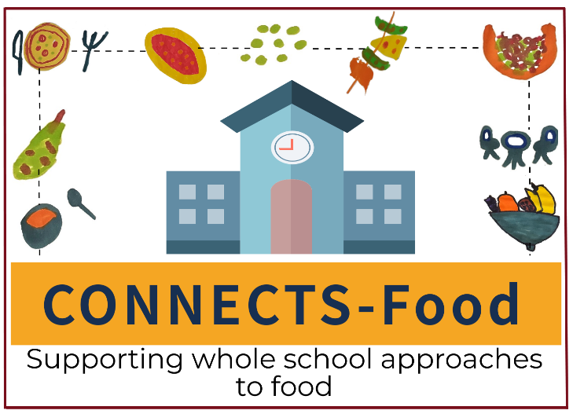
CONNECTS Food website privacy policy
Our contact details:
Name: CONNECTS-Food study team
Address: Department of Health Sciences, University of York, Heslington, York, YO10 5DD
Email: wendy.burton@york.ac.uk
The type of personal information we collect
We currently collect and process the following information:
- Type of stakeholder
- Type of school
- School district
- School postcode
How we get the information and why we have it
The personal information we process is provided to us directly by you in order for you to use our interactive statement builder tool.
We use the information that you have given us to produce a report on which type of stakeholders are using our website and the school they are from.
We do not share your information with anyone else external to the CONNECTS-Food study team. Only aggregated data are shared.
Under the General Data Protection Regulation (GDPR), the lawful bases we rely on for processing this information are:
- Your consent. You can decide whether or not you provide this information. You are able to remove your consent at any time by contacting wendy.burton@york.ac.uk
- We have a legitimate interest. We would like to know the characteristics of website users to understand its potential impact in supporting whole school approaches to food.
How we store your personal information
Your information is securely stored in a password protected Wix database, which only the CONNECTS-Food study team and named website administrator has access to. We will keep your details for five years. We will then dispose your information by permanently removing from all archived projects and associated databases.
Your data protection rights
Under data protection law, you have rights including:
Your right of access - You have the right to ask us for copies of your personal information.
Your right to rectification - You have the right to ask us to rectify personal information you think is inaccurate. You also have the right to ask us to complete information you think is incomplete.
Your right to erasure - You have the right to ask us to erase your personal information in certain circumstances.
Your right to restriction of processing - You have the right to ask us to restrict the processing of your personal information in certain circumstances.
Your right to object to processing - You have the the right to object to the processing of your personal information in certain circumstances.
Your right to data portability - You have the right to ask that we transfer the personal information you gave us to another organisation, or to you, in certain circumstances.
You are not required to pay any charge for exercising your rights. If you make a request, we have one month to respond to you. Please contact us at wendy.burton@york.ac.uk if you wish to make a request.
How to complain
If you have any concerns about our use of your personal information, please contact the Chair of the University of York’s Department of Health Sciences’ Research Governance Committee at stephen.holland@york.ac.uk. For anyone with concerns specifically about the way their data has been handled, please contact University of York’s Data Protection Officer (Durham Burt, email: dataprotection@york.ac.uk). You can also report and unresolved concerns to the Information Commissioner’s Office at www.ico.org.uk/concerns.
To find out more about how your data will be managed by the CONNECTS Food team/University of York please refer to the following web pages:
https://www.york.ac.uk/records-management/dp/
https://www.york.ac.uk/records-management/dp/guidance/gdprcompliantresearch/
https://www.york.ac.uk/records-management/dp/your-info/generalprivacynotice/
https://www.york.ac.uk/healthsciences/research/trials/trials-gdpr/
https://www.york.ac.uk/healthsciences/research/trials/trials-gdpr/research-partcipants/

